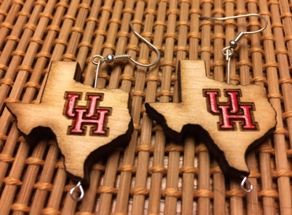Earrings Outreach

# Set Up

## Hours to Days Before Event

1. Precut *at least* one full board worth of Texas pieces (directions below) and drill half of them. Drilled pieces will be the pieces the girls can paint on to have a souvenir. For larger events 2+ boards may be needed. Separate these in the clearly marked bags to save time.
2. For large events 3D print a lot of little robot souvenirs to fill the bag (use file named ????).
3. Double check to see if all parts for all activities are there. (Drill bits, Goggles, Hair ties).
4. 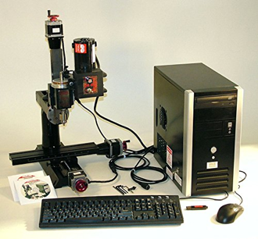Print-off instructions

## CNC machine

1. Ensure that the drill attachment is attached to the CNC machine. The proper attachment should screw in at the top. If it is not attached, it should be found in the compartment at the top of the bench.
2. Place Texas-shaped Jig into CNC clamp and tighten to the point that a Texas can easily slide in and out of the jig but not move side to side.
3. Plug in all X Y & Z axis stepper motors to the corresponding cables coming out of the computer to the left of the CNC bench.
4. Turn on the computer (and monitor). When the computer is on, open the program “Sherline Mill MM”
5. The program should default to having the Manual tab highlighted in green. Move the axis with the red wheels to the position you want to start drilling and click “ALL ZERO” on the bottom right. This will set your origin point (AKA the cutting point).
6. Flip the switch on the left-hand side of the computer, red light should turn on. This ensures that the CNC machine is taking inputs from the computer and make it so you cannot move the axis
7. At the top of the window, click “Auto”.
8. At the bottom of the screen click “Open…” and navigate to “TexasEarringFastv02”.
9. [do a dry-run] Do not have a piece in the machine and do not run the drill. Click “Run”.
10. Test the CNC machine by doing the steps below in activities. If the Texas does not cut all the way through or scrapes on the panhandle, adjust zero accordingly.

## Laser Cutter

1. Log in to laser cutter computer with any login and turn on the laser cutter.
2. Place piece of wood you want to cut into the bed.
3. Adjust bed height with the up and down arrows on the right of the machine such that the laser level measure is at first divot of the calibration tool (tool is stuck to laser with a magnet, has a black base and white stem with divots).
4. In the laser cutter menu, choose the file “UHandTEXAS3color4x4.pdf”. This one should be saved and should be colored black, red, and green for 3 different cut types.
5. Adjust the amount of Texas shapes being cut by pressing the button on the left hand that has 4 circles and adjusting quantity to 1 and 1 in each column.

## Other

1. Move two tables outside and tape down paper/copies of the school newspaper down to protect the table from the nail polish the girls will be using to paint the earrings.
2. Move in a lot of chairs. Preferably, no chairs with fabric on them in case nail polish is dropped on the chairs.
3. Set out the nail polish, acetone, eyelets, earring hooks, earring backs, jeweler pliers, and diagonal cutters. Do not place out the Texas shapes or the girls will grab as many as they want.
4. Move 3D printers and robotic arm into the hallway to run automatically to look exciting. If there is extra time they can be explained to the girls as well.
5. Ensure that the 3D printer is printing something research important or a quick demo for the guests to watch. I like to set out the 3D printer souvenirs in front of the printers as examples.
6. Run the UR3 with a looping code so it’s always active. We have some saved options to choose from or it can be chosen based on your own waypoints. Double check that nothing is in the way of the robot arm.

# Activities (Take Pictures During the Event)

## Painting activity (3-4 People)

1. Hand guests 1 to 2 drilled Texas shapes depending on how many pieces are available and how many expected guests there will be.
2. Demonstrate how to assemble a Texas earring.
   1. Put eyelet in from the bottom of Texas shape
   2. Use diagonal cutters to trim eyelet so there is just enough to create a ring at the top (cut level with top of panhandle)
   3. Use *jeweler pliers* to create a ring at the top of the eyelet by curling the wire around the plier
   4. Add hook to this ring before closing it. Then close the ring entirely.
   5. Ta-Da! Earring!
3. Set the students free to create. Help students who struggle. Smile often.
4. About halfway through or if questions are asked, give a spiel about 3D printers and the robot arm.
5. If only 1 Texas was given at the beginning of the painting session, give them a second one from the pre-painted bag.

## In lab activities (4 people)

1. Introduce the lab.
2. Emphasize how important safety is to the lab. Give student goggles and hair ties. They can keep the hair ties but return the goggles at the end of the tour

### Laser Cutter

1. Give a small introduction to the laser cutter
2. Move Texas shapes to cut-able location. Since you are cutting a small area try a used board.
3. Turn on air and filter and close the lid of the laser cutter. (Or ask the children to do it)
4. Press the play button.
5. Encourage student not to look directly at the laser.
6. Send them on to the Drill Press.

### Drill Press

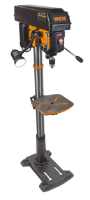

Drill bit drill press

1. Give a tiny introduction to the drill press. Double-check that their hair is tied back.
2. Drill a piece.
3. Emphasize why a drill press is bad and why you can make it automatic with a CNC machine. Send them on to the CNC Machine.

### CNC machine

1. Give a small introduction to the CNC machine
2. Place piece into jig
3. Click “Resume” in the program. This should move CNC machine into place for drilling.
4. Flip the switch above the drill to the “On” position.
5. Click “Run” in the program.
6. Flip the switch above the drill to the “OFF” position and wait until drill has stopped turning to remove piece.
7. Repeat steps 2 through 6 until the end of time or until the event ends.

# Breakdown

## CNC machine

1. Make sure switch above the drill of the CNC machine is flipped to “OFF”
2. Flip the switch to the left of the computer down such that the red light is off.
3. Turn off the computer.
4. Unplug the axis, if you so wish.

## Laser Cutter

1. Make sure switch above the drill of the CNC machine is flipped to “OFF”
2. Flip the switch to the left of the computer down such that the red light is off.
3. Turn off the computer.
4. Unplug the axis, if you so wish.

## Other

1. Clean up painting table. This is a good time to see if there is a need to reorder any of the supplies. If so, make an excel sheet and send it to Dr. Becker! The excel sheet is at https://github.com/aabecker/RoboticSwarmControlLab/tree/master/Outreach/Robots%20to%20make%20Jewelry
2. Return the printers and the robot arm back to their respective positions in the lab.

Wire cutter, round-nose pliers, needle-nose pliers

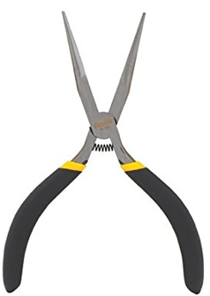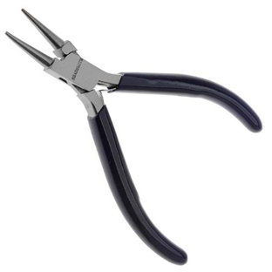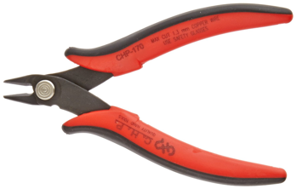

Eye pins Earring hooks Nail polish

